WHAT IS AMFCC PART-TIME?

It is an affiliate programme of Africa Multination For Christ College, offering off-campus training to those who are not in full time ministry, but sense the need to deepen one's knowledge in God's word with the intention to become mature spiritually and being grounded therein. It is also a leadership training tool for ZAOGA FIFMI.

The word of God (the Bible) is taught in its fullness since it is the inspired word, written for reproof,
correction and training for righteousness, so that the man of God may be equipped for every good work. 2 Timothy 3: 16- 17

Here, students are brought into the secret place of the Most High God, through a life developed by prayer and the Word of God. Like the disciples of Jesus Christ, students will proclaim the powerful message of deliverance so needed today.

The secret of Prof. E.H. Guti’s ministry, which has touched more than 160 nations and states around the globe is revealed to the students through this programme.

ITS PHILOSOPHY.

It is a programme where the cross can be established. The scriptures are applied daily for God's Glory. Since it is built upon the revelation of Jesus Christ, the Holy Spirit has the liberty to work in and through many aspects of the students to reveal Christ.

ITS MISSION

- To equip men and women of God for the ministry.
- To train young people to reach out to their peers in schools, colleges, hospitals, prisons, e.t.c.
- To train missionaries who will reach other nations with the fulfillment of the Great Commission.
- To provide a firm foundation for a Christian’s life, which is victorious through the word of God.
- To promote or stir up the gifts that are in the members of the body of Christ through effective training.
- To produce preachers who can rightly divide the word of truth. 2 Timothy 2:15.

Qualification for training.

- Every born again person who is literate can enroll for training provided he/she is available for the lessons and is able to pay the required fees.
Enrolled students must ensure that they pay their fees at the beginning of every term bearing in mind that these fees are for the running of the school during the term. The National office may assist in setting the minimum amount of fees for a marked period, but we feel that the local schools council, putting into consideration their expenditure and the income base of the prospective students, must do this.

Diplomas are given to those who complete the required courses in the two-year programme and passed the national examinations. We encourage students to exercise the highest level of commitment during this period so as to acquire as much information as possible rather than to just aim for the paper (diploma.).
Furthermore, we are aware of the need of competent teachers/lecturers and we have made a provision for refresher courses for the same cause and have furnished most schools with the necessary information in form of updated lectures for particular subjects. Those who have not yet acquired these lectures can contact our mother college. The lectures are available at a minimal production cost.
All the other papers required to run the school professionally are also available at AMFCC Harare and are issued free of charge. Every school in operation, however, is expected to complete the Affiliation Form to be returned to the National office with a stipulated amount of affiliation fees (subject to review) for administration purposes.

Programme Perspective

We encourage both the teachers and the students to create an environment for learning and we encourage the students to motivate their teachers by paying due respect, attendance participation and co-operation. Representatives from the National Office will from time to time visit the evening schools in order to ensure that the standards are met and the school get all the necessary help need for the smooth running of the Part-time schools programme.
Generally, the school terms are similar to the secular ones unless with special consent on the part of students and teachers at a particular place.

FOR FURTHER INFORMATION ON THIS PROGRAMME CONTACT

THE REGISTRAR
AMFC COLLEGE (PART-TIME SCHOOLS DPT)
P.O. BOX 258
WATERFALLS
HARARE, ZIMBABWE
amfccparttime@zaogafif.co.zw
+263 714 060 116, +263 775 159 473

OR

THE REGISTRAR
AMFC COLLEGE (PART-TIME SCHOOL)

____________________________________

____________________________________

____________________________________

AFRICA MULTINATION

FOR CHRIST

COLLEGE

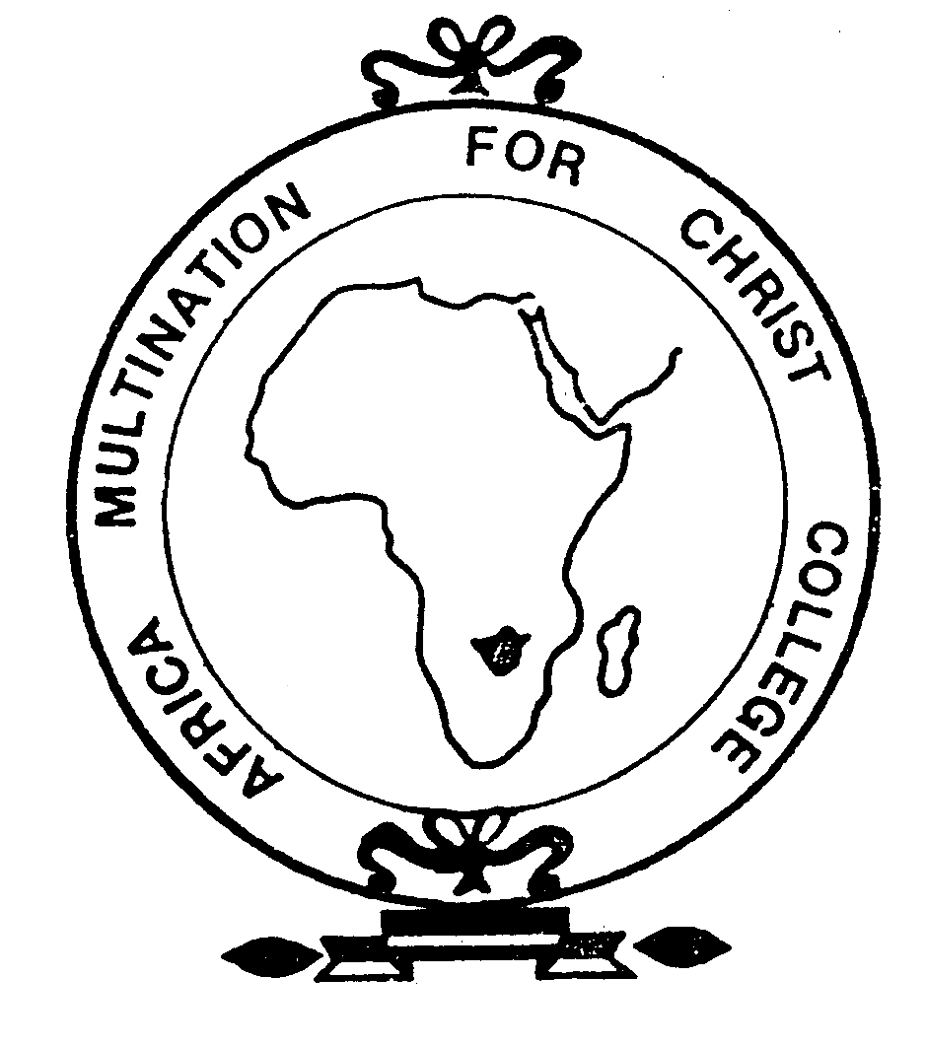

PART-TIME SCHOOLS PROGRAMME

What is it?

